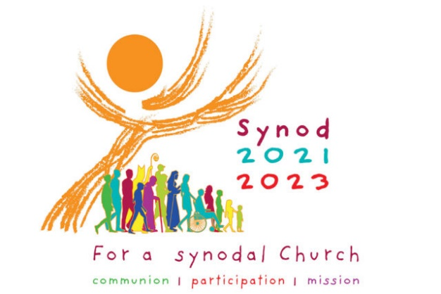
Catholic Diocese of Wilmington
Synod Listening Session
Instructions for Small Group Leaders

Role of the Small Group Leader
During a Synod Listening Session, if there is a large gathering, people present are broken up into small groups. Each small group has a Leader. The primary task of the Leader is to guide and facilitate the prayerful reflection and sharing of the small group based on the Two Primary Questions. The Leader participates as a contributing member in the group sharing, but is also in charge of leading and facilitating this process for the group.
When the head Facilitator for the Listening Session instructs that it is time for the small group sharing, the Leader will begin to direct his/her group in this part of the process.
Preparation for Small Group Sharing
The Leader should first ensure that everyone has a copy of the Listening Session Participant Worksheet. This worksheet provides the Two Primary Questions for reflection and space for participants to jot down their thoughts. The Leader should also ensure that:
- The Reporter for the group is present and has the reporting instructions and the Small Group Report Form to capture the responses for the group.
- Ensure everyone in their group who needs a writing utensil has one.
- The Participant Handout, Report Form, and writing utensils are in place. Ordinarily, these are provided in advance by the head Facilitator for that Listening Session.
- Have a means of keeping time to ensure that everyone has an opportunity to share their thoughts.

Conducting the Small Group Sharing
(1) Question #1: Introduce & Reflect - The Leader begins the group reflection by reminding the group that the task at hand is first to listen to the voice and promptings of the Holy Spirit in their hearts as the group together reflects and shares on the Two Primary Questions. These Two Primary Questions are provided at the end of this document. The leader then slowly reads the First Question along with its focusing questions and then invites the group to pray and reflect in silence for about 5 minutes. Silence can be uncomfortable, but is necessary to hear the voice of the Lord.

(2) Question #1: Sharing - After the period of silent prayer, the Leader invites the members of the group one-by-one to share their responses to the First Question. The Leader should also share his/her own response. Each person should be given about 2 to 3 minutes to respond and share their thoughts; depending on the size of the group more or less time could be given to each person.
The Leader is also the timekeeper and keeps the discussion and sharing of the participants moving along. The Leader kindly interjects if an individual begins to dominate the sharing and speaks for too long. The point of the sharing is for the all of the group members to have the opportunity to speak and to do so freely while the other members simply listen to what is being said. There should be no arguing, defending, or debating; this is a listening session in the strictest sense. The Leader keeps everyone focused and maintains the spirit and purpose of the small group listening and sharing.
(3) Question #1: Summarize - The Leader should then help the Reporter to discern and identify the three primary Strengths and the primary Challenges that surfaced as a result of everyone’s responses in the small group sharing for this First Question. This can be done by asking the group which points that were brought forward resonated with other members. The Reporter will then record these three Strengths and the three Challenges on the appropriate form for the group.
(4) Question #2: Reflect - Once everyone has had the opportunity to share their response for the First Question and the Reporter’s work is finished, the leader then repeats the process and slowly reads the Second Question along with its focusing questions. The Leader then invites the group to pray and reflect in silence for about 5 more minutes.
(5) Question #2: Sharing - After the period of silent prayer, as before, the Leader then invites the members of the group again one-by-one to share their response to the Second Question. The Leader should again share his/her own response. Each person should be given about 2 to 3 minutes to respond. The Leader should continue to keep time and ensure that the sharing moves along and no one speaks excessively or inappropriately.
(6) Question #2: Summarize - The Leader should then help the Reporter to discern and identify at least three but no more than six Action Steps that were generated as a result of everyone’s responses in the small group sharing for the Second Question. This again can be done by consulting the group about which points were brought forward and resonated with the other members. The Reporter will then record these three to six Action Steps on the appropriate form for the group.

Submission & Sharing of Results
Once everyone has had the opportunity to share their response for the Second Question and the Reporter’s work is completed, the head Facilitator for the Listening Session will call all small groups back to attention. The head Facilitator may then invite the Leaders/Reporters of some or all of the small groups to share a Strength, Challenge, and/or Action Step with the gathering at-large. At the conclusion of this final sharing the Leader in conjunction with the Reporter is to ensure that the Small Group Report Form is completed properly and submitted to the head Facilitator before leaving the Listening Session that day.
First Question with Focusing Questions
The following represents the First Question of the Synod proposed by Pope Francis. Accompanying it are additional focusing questions which speak to the First Question and help participants to articulate a response to this question. This question will elicit two types of responses either: (1) A Strength of how the Church journeys together well or (2) A Challenge, an area where the Church may need improvement. The input shared from the group participants for this question should be placed in one of these two categories by the Leader and the Reporter for the written responses on the form to be submitted.
FIRST QUESTION: The Church in announcing the Gospel journeys together.
How is this “journeying together” happening today in your local Church?

In thinking about our Strengths:
• What are our positive experiences of journeying together in our local Church?
• What joys did those experiences bring?

In thinking about our Challenges:
• What difficulties and obstacles have we encountered?
• What wounds did those experiences reveal?
• What voices are missing or not present among us?
• What insights have those experiences elicited?

Second Question with Focusing Questions
The following represents the Second Question of the Synod proposed by Pope Francis. Like the previous question accompanying it are additional questions which speak to the Second Question and help participants to articulate a response to this question. This question will elicit one type of response called an Action Step. An Action Step is what someone thinks the Church is being called to do to journey together better. The input shared from the group participants for this question should be recorded in the appropriate section on the form to be submitted.

SECOND QUESTION: What steps does the Spirit invite us to take in order to grow in our “journeying together”?

In thinking about some Action Steps we could take:
• What pathways forward are opening up for our local Church (i.e. diocese, parish, school, or organization)?
• Where in these experiences does the voice of the Holy Spirit resound?
• In what way is the Spirit calling us to reach out and how?
• What are the areas for change for our Church and what steps can be taken?

Best Practices: Tips for Effective Small Group Sharing
The Leader of the small group should strive to adopt these following best practices for effective sharing and listening. Journeying together in a small group means:
1. I affirm that this listening session is a safe place to talk.
2. I treat each person and what they have to say with reverence, respect, dignity, and confidentiality.
3. I allow one person to speak at a time and listen with an open mind, even if I do not agree with their perspective.
4. Since our conservation is to promote dialogue:
a. When I speak my purpose is to advance the conversation of the group.
b. I will strive to understand that everyone’s experience is different, and I will be acutely aware of my attitude and tone of voice in all interactions.
5. I will be prudent and limit how long I speak so that everyone has time to share.
6. I only speak once until everyone has had an opportunity to share.
7. As a participant, when I tell others of our experience of the listening session, I will not attribute anything we share to a particular person or group.
There are additional suggestions for effective small group sharing in the Diocese of Wilmington’s Consultation Process & Handbook available on the diocesan website.

The content contained in this document is adapted from the following:
- Process for Facilitating Synodal Consultations (Leadership Roundtable)
- Official Vatican Synod website (Vatican-Holy See Synod Office)
- USCCB Synod website

