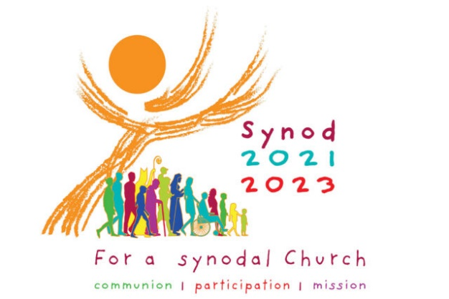
Catholic Diocese of Wilmington
Synod Listening Session
Instructions for Reporters

Role of the Reporter
During a Synod Listening Session, when there is a large group gathering, people present are broken up into smaller groups. Each small group has a Reporter. The Reporter captures the main points of what each person shares in the group in response to the Two Primary Questions as defined at the end of this document. The Reporter participates as a contributing member in the group by sharing his/her own thoughts while simultaneously taking notes and synthesizing a report of the group’s dialogue.
Using the Small Group Report Form, the Reporter, with the assistance of the group, will:
- Determine the main points of the discussion.
- Succinctly record these main points on the Small Group Report Form.
At the conclusion of the small group discussion the reporter will then submit the completed Small Group Report Form to the Head Facilitator of the Listening Session. Towards the end of the Listening Session, the Reporter also may be asked to share some of the main points from their small group sharing.

First Question with Focusing Questions
The following represents the First Question proposed by Pope Francis. Accompanying it are focusing questions meant to further explain the First Question. These are intended to help participants articulate a response to this question.
The First Question will elicit two types of responses:
(1) a Strength about how the Church is journeying together or
(2) a Challenge, an area where the Church may need improvement.
As the Reporter listens to the input from the group he/she will identify whether the response is categorized as a Strength or a Challenge. The First Question is formulated as follows:

FIRST QUESTION: The Church in announcing the Gospel journeys together.
How is this “journeying together” happening today in your local Church?

In thinking about our Strengths:
• What are our positive experiences of journeying together in our local Church?
• What joys did those experiences bring?

In thinking about our Challenges:
• What difficulties and obstacles have we encountered?
• What wounds did those experiences reveal?
• What voices are missing or not present among us?
• What insights have those experiences elicited?

Reporting on the First Question
Once the small group sharing and discussion on the First Question has been completed the Reporter then needs to record the summary points on the Small Group Report Form. The Reporter should write down on the form only three Strengths and then only three Challenges that came from the group discussion.

Obtaining Consensus

It is very likely that the group discussion will generate more than three Strengths and three Challenges. If this is the case the Small Group Leader or the Reporter need to work with the small group to identify and list in order of importance only three of each. For both Questions, if there is a lack of consensus, the Reporter and the group Leader will make the final determination what to record for the small group, making the best judgment possible about which ones should be submitted.

Second Question with Focusing Questions
The following represents the Second Question of the Synod proposed by Pope Francis. As with the previous question accompanying it are additional questions which speak to the Second Question and help participants to articulate a response to this question. This question will elicit one type of response called an Action Step. An Action Step is what someone thinks the Church is being called to do to journey together better. The input shared from the group participants for this question should be recorded in the appropriate section on the form to be submitted.

SECOND QUESTION: What steps does the Spirit invite us to take in order to grow in our “journeying together”?

In thinking about some Action Steps we could take:
• What pathways forward are opening up for our local Church (i.e. diocese, parish, school, or organization)?
• Where in these experiences does the voice of the Holy Spirit resound?
• In what way is the Spirit calling us to reach out and how?
• What are the areas for change for our Church and what steps can be taken?

Reporting on the Second Question

Based on the group sharing for the Second Question, the Reporter needs to write down on the form at least three but no more than six Action Steps that came from the group discussion.

Obtaining Consensus

As with the First Question if more than six Action Steps are generated, the Small Group Leader or the Reporter need to work with the small group to identify and list in order of importance at most six responses in total.

Length of Responses

Each Strength, Challenge, and Action Step that is recorded should be as succinct and to the point as much as possible – no longer than a sentence in length. A response written as a clearly developed bullet point is acceptable as well. It will be useful for the Reporter to take notes on a separate sheet of paper or notepad other than the Small Group Report Form. The Reporter can then use his/her notes as a guide to formulate the final responses that will be written on the report form that is to be submitted at the conclusion of the Listening Session. The final summary results captured on the Small Group Report Form may then be shared with the larger group following the small group discussions as guided by the Head Facilitator.

Tips for Good Reporting
Good reporting on a small group sharing is characterized by the following attributes:
● Reporting does not include everything that is said.
● Reporting is not a verbatim account of the consultation.
● Use bullet points as much as possible.
● Record the points people made in the consultation without adding your own biases, emotions or experiences connected to content.
● Provide quotes where appropriate, without attribution to a particular person or group.
● Do not attribute comments to specific individuals for purposes of confidentiality.
● Record areas of agreement, whether that agreement is formally or informally established.

There are additional suggestions for effective small group sharing in the Diocese of Wilmington’s Consultation Process & Handbook available on the diocesan website.

The content contained in this document is adapted from the following:
- Process for Facilitating Synodal Consultations (Leadership Roundtable)
- Official Vatican Synod website (Vatican-Holy See Synod Office)
- USCCB Synod website

