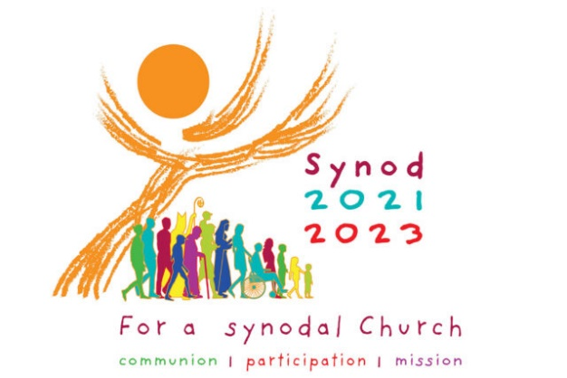
Catholic Diocese of Wilmington
Synod Listening Session
Information for Participants

An Invitation to Listen
Bishop Koenig is inviting you and everyone in the Diocese of Wilmington to participate in Listening Sessions as part of the recent Synod process started by Pope Francis in 2021. Pope Francis is asking the entire Church throughout the world to reflect prayerfully on how the Holy Spirit is calling us to “journey together” as a Church to God’s heavenly kingdom. In this spirit, the Listening Session experience will provide an opportunity for us to listen to God in our own hearts, to share our experiences, and then to listen to the voices of one another. In effect, this will help us all to discover together new pathways forward guided by the Holy Spirit. This will also assist us in realizing the goals of the Synod for better communion, increased participation, and clarity of our mission as Christians in our present time.
Listening Session Format
Each Listening Session will open with prayer and Scripture. After being instructed about the process, those present will then be broken out into small groups. Each small group will have a designated Leader who will facilitate the reflection and sharing within the group. Each group will respond to the two questions of the Synod posed by Pope Francis as he presents to us,
The Church in announcing the Gospel journeys together. Therefore,
- How is this journeying together happening today in your local Church?

- What steps does the Spirit invite us to take in order to grow in our
journeying together?

After silent prayer and reflection each person within the small group will have the opportunity to respond to the two questions and share with the group what the Holy Spirit has put on their mind and heart. A designated Reporter from the small group will record the input from the group sharing and submit a summary report of the group’s discussion. All recorded input will be anonymous and will not be attributed to individual persons, providing freedom to share openly.
If there is more than one small group present, the Listening Session will prayerfully conclude after each small group briefly shares their results with the group at-large.
Each Reporter will submit their written small group report to the head Facilitator, who will then submit a summary report of the entire Listening Session experience to the diocese. The diocese will then compile a final report to be submitted to the United States Conference of Catholic Bishops. Their findings will be represented in the Synod with Pope Francis in 2023.
Additional Synod Information
More information regarding the Synod process may be found at: www.cdow.org/synod

