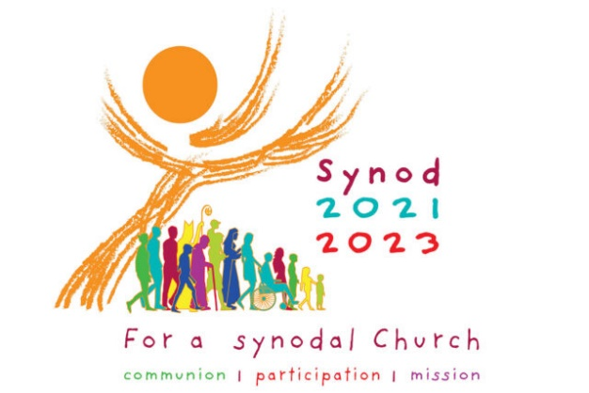

Prayer for the Synod: Adsumus Sancte Spiritus

Every session of the Second Vatican Council began with the prayer Adsumus Sancte Spiritus, the first word of the original Latin, meaning “We stand before You, Holy Spirit,” which historically has been used at councils, synods, and other Church gatherings for hundreds of years and is attributed to Saint Isidore of Seville (c. 560- 4 April 636). As we embrace this Synodal Process, this prayer invites the Holy Spirit to be at work in us so that we may be a community and a people of grace.

We stand before You, Holy Spirit,
as we gather together in Your name.

With You alone to guide us,
make Yourself at home in our hearts;
Teach us the way we must go
and how we are to pursue it.

We are weak and sinful;
do not let us promote disorder.
Do not let ignorance lead us down the wrong path
nor partiality influence our actions.

Let us find in You our unity
so that we may journey together to eternal life
and not stray from the way of truth
and what is right.

All this we ask of You,
who are at work in every place and time,
in the communion of the Father and the Son,
forever and ever.
Amen.

Best Practices for Effective Sharing and Listening

As you prepare for the synodal consultation we ask all participants to embrace the following best practices for our conversation. In this way we can model being a synodal community, together on the journey.

- This consultation is a safe place to talk – we treat each other and what anyone has to say with reverence, respect, dignity, and confidentiality.

- We allow one person to speak at a time and we listen with an open mind, even if we do not agree with his or her perspective.

- Since our conversation is to promote dialogue:
  - When I speak, my purpose is to advance the conversation.
  - I will strive to understand that everyone’s experience is different, and I will be acutely aware of my attitude and tone of voice in all interactions.

- I will be prudent and limit how long I speak so that everyone has time to share.

- I only speak once until everyone has had an opportunity to share.

- As a participant, when I tell others of our experience of the consultation, I will not attribute anything we share to a particular person or group.

Notes

FIRST QUESTION: The Church in announcing the Gospel journeys together.
How is this “journeying together” happening today in your local Church?

In thinking about our Strengths:
• What are our positive experiences of journeying together in our local Church?

• What joys did those experiences bring?

In thinking about our Challenges:
• What difficulties and obstacles have we encountered?

• What wounds did those experiences reveal?

• What voices are missing or not present among us?

• What insights have those experiences elicited?

Notes

SECOND QUESTION: What steps does the Spirit invite us to take in order
to grow in our “journeying together”?

In thinking about some Action Steps we could take:

• What pathways forward are opening up for our local Church (i.e. diocese, parish, school, or organization)?

• Where in these experiences does the voice of the Holy Spirit resound?

• In what way is the Spirit calling us to reach out and how?

• What are the areas for change for our Church and what steps can be taken?

Notes

Sending Forth Prayer

Leader: Let us take a moment of quiet as we reflect on what we have done here today and give thanks for the opportunity to have spent this time together with the Lord and with one another.

Leader: Dearest brothers and sisters, in his letter St. James tells us, “Humbly welcome the word that has been planted in you and is able to save your souls. Be doers of the word and not hearers only…” (James 1:21b-22a).

Leader: Let us pray.

All: Come Holy Spirit, we ask you, that by your inspiration,
may all of our prayers and actions always begin from you
and inspire others to know you more deeply,
that we may all lovingly journey together side-by-side
to your heavenly kingdom.
We ask this through Christ our Lord. Amen.

Leader: Let us go forth sharing a sign of Christ’s peace.
(All exchange a sign of peace.)

